Rollno- 160724754073(ai-b)
Week8(21.04.26)
#27.implement confusion matrix
from sklearn.metrics import confusion_matrix,precision_score,recall_score,f1_score,roc_curve,auc
import matplotlib.pyplot as plt
y_true=[1,0,1,0,1,0,1,0]
y_pred=[1,1,1,0,0,0,1,0]
cm=confusion_matrix(y_true,y_pred)
print("confusion matrix:",cm)
print("precision:",precision_score(y_true,y_pred))
print("Recall:",recall_score(y_true,y_pred))
print("F1:",f1_score(y_true,y_pred))
y_score=[0.9,0.6,0.8,0.3,0.4,0.2,0.85,0.1]
fpr,tpr,_=roc_curve(y_true,y_score)
roc_auc=auc(fpr,tpr)
print("AUC:",roc_auc)
plt.plot(fpr,tpr)
plt.xlabel("FPR")
plt.ylabel("TPR")
plt.title("ploc curve")
plt.show()
o/p-
confusion matrix: [[3 1]
[1 3]]
precision: 0.75
Recall: 0.75
F1: 0.75
AUC: 0.9375

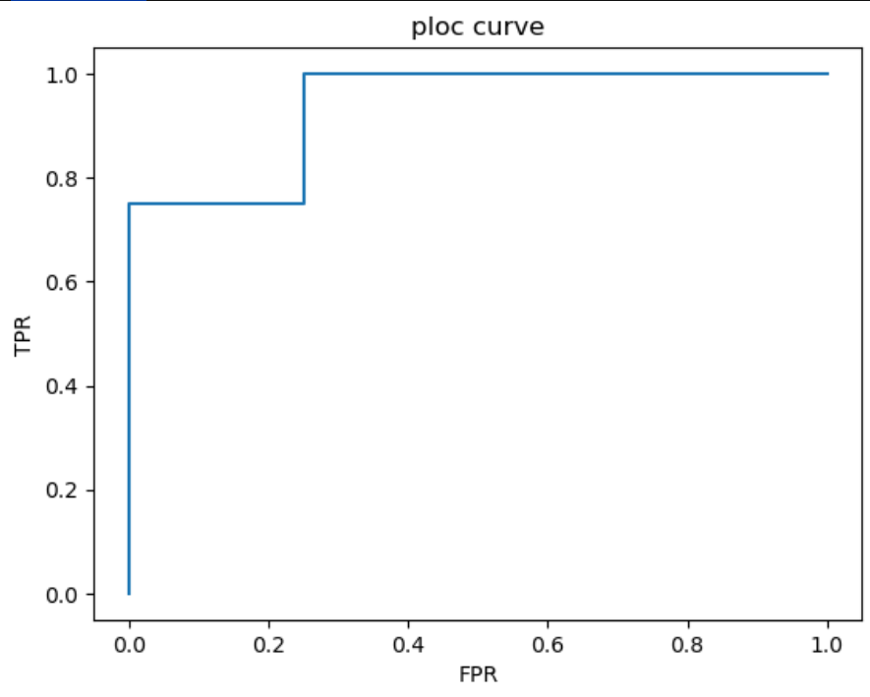
#28 SVM
from sklearn import svm
x=[[2,2],[4,4],[2,0],[0,2]]
y=[1,1,-1,-1]
model=svm.SVC(kernel='linear')
model.fit(x,y)
print(model.predict([[0,0]]))
o/p
[-1]

#29 polynomial regression
import numpy as np
import matplotlib.pyplot as plt
from sklearn.preprocessing import PolynomialFeatures
from sklearn.linear_model import LinearRegression
x=np.array([1,2,3,4]).reshape(-1,1)
y=np.array([1,4,9,16])
poly=PolynomialFeatures(degree=2)
x_poly=poly.fit_transform(x)
model=LinearRegression()
model.fit(x_poly,y)
y_pred=model.predict(x_poly)
plt.scatter(x,y)
plt.plot(x,y_pred)
plt.show()
o/p
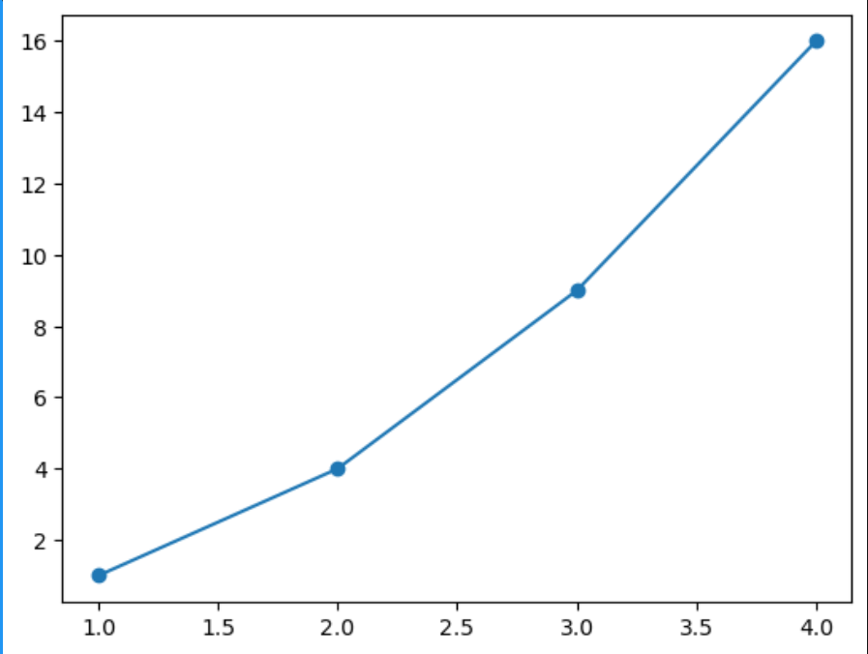
#30 decision tree
from sklearn.tree import DecisionTreeClassifier
x=[[1,1],[1,0],[0,1],[0,0]]
y=[0,1,1,0]
model=DecisionTreeClassifier()
model.fit(x,y)
print(model.predict([[0,1]]))
o/p
[1]

#30 decision tree
from sklearn.tree import DecisionTreeClassifier
x=[[1,1,1],[1,0,1],[0,1,0],[0,0,0]]
y=[1,1,0,0]
model=DecisionTreeClassifier()
model.fit(x,y)
print(model.predict([[1,0,1]]))
o/p
[1]

Week9(28.04.26)
#32.Implement the LASSO model
from sklearn.linear_model import Lasso
import numpy as np
X=np.array([[1,25,160],[2,30,165],[3,35,170]])
y=np.array([30000,40000,50000])
model=Lasso(alpha=0.1)
model.fit(X,y)
print(model.coef_)
o/p
[9.99973000e+03 4.80000000e-02 3.33066907e-18]

#Lasso supervised
import numpy as np
from sklearn.linear_model import Lasso
x=np.array([[1,5,2],[2,6,4],[3,7,6],[4,0,8]])
y=np.array([5,10,15,20])
model=Lasso(alpha=0.1)
model.fit(x,y)
print("coefficients:",model.coef_)
o/p
coefficients: [ 0. -0. 2.48]

#33 similarity and distances
import numpy as np
from scipy.spatial import distance
from scipy.stats import pearsonr
point1=np.array([2,3])
point2=np.array([5,7])
euclidean=distance.euclidean(point1,point2)
manhattan=distance.cityblock(point1,point2)
chebyshev=distance.chebyshev(point1,point2)
hamming=distance.hamming(point1,point2)
cosine_distance=distance.cosine(point1,point2)
cosine_similarity=1-cosine_distance
set1,set2=set(point1),set(point2)
jaccard_similarity=len(set1&set2)/len(set1|set2)
r=pearsonr(point1,point2)
print("euclidean distance",euclidean)
print("manhattan distance",manhattan)
print("chebyshev distance",chebyshev)
print("hamming distance",hamming)
print("cosine distance",cosine_distance)
print("cosine similarity",cosine_similarity)
print("jaccard similarity",jaccard_similarity)
print("pearsoner correlation",r)

o/p
euclidean distance 5.0
manhattan distance 7
chebyshev distance 4
hamming distance 1.0
cosine distance 0.0005198856603004787
cosine similarity 0.9994801143396995
jaccard similarity 0.0
pearsoner correlation PearsonRResult(statistic=1.0, pvalue=1.0)

#34.implement the k-means clustering(unsupervised learning)algorithm
import numpy as np
A=np.array([[2,3],[3,4],[4,2]])
B=np.array([[8,7],[9,6],[10,8]])
P=np.array([5,5])
CA=A.mean(axis=0)
CB=B.mean(axis=0)
dA=np.linalg.norm(P-CA)
dB=np.linalg.norm(P-CB)
if dA<dB:
print("point belongs to cluster A")
else:
print("point belongs to cluster B")

o/p
point belongs to cluster A

